

**ITS30305107816 Web Programming**

**Assignment 1**

**Cover Sheet**

**Hand out Date: 24th October 2017 (Tuesday)**

**Hand in Date : 8th November 2017 (Wednesday)**

**Presentation time: 7th/8th November 2017 (During class time)**

**WEIGHTAGE: 15%**

**Instructions to students:**

* The assignment should be attempted individualy
* Complete this cover sheet and attach it to your assignment – this should be your first page!

|  |  |
| --- | --- |
| **Student declaration:** | |
| ***I declare that:***   1. ***I understand what is meant by plagiarism*** 2. ***The implication of plagiarism have been explained to us by our lecturer***   ***This project is all our work and I have acknowledged any use of the published or unpublished works of other people.*** | |
| **Name** | **Student ID** |
| **Au Yeong Leng (0330548)** | 0330548 |

*Avoid copy and paste job in your report and it is considered as plagiarism. Plagiarism in all forms is forbidden. Students who submit plagiarised assignment will deserved a 0 marks.*

TABLE OF CONTENTS

Introduction 3

* Purpose of the website
* Target Audience

Website design 4

* Site Map
* Story Board

Appendix 6-74

* Screen Captures
* Source Code

References 75

**Introduction**

I created this website with the concept in mind that nowadays, young adults and adolescents alike are mostly on the social media application, ‘Instagram’. It is a social media whereby users are able to post pictures or videos onto their account as well as view others’. One of the popular trending types of posts majority of the users would be about food. It has become a trend for not just Instagrammers, but even the adults and senior citizens to capture their visually stunning food and sharing them before actually eating it. Thus, I hoped that this website will be able to recommend the popular places in Malaysia that sell food that is both visually pleasing and delicious. Hence, my target maket is mainly aimed at teenagers, young adults and adults. However, it is also welcome to any inividual that just wants to try something new.

**Website Design**

**Site Map**

**Sign-In Page**

(Sign In.html)

**More**

(More.html)

**Feedback Form**

(Feedback.html)

**Food**

Ru Di Fook

(Food6.html)

Leaf & co

(Food5.html)

Botanica Deli

(Food1.html)

Merchant’s Lane

(Food2.html)

Quartet TTDI

(Food3.html)

Velocity cafe (Food4.html)

**Home Page**

(Home Page.html)

**Story Board**

1. Food Page
2. Home Page

5)Feedback Page

4) More Page

3) Sign In Page

**Appendix**

**Screen Captures**

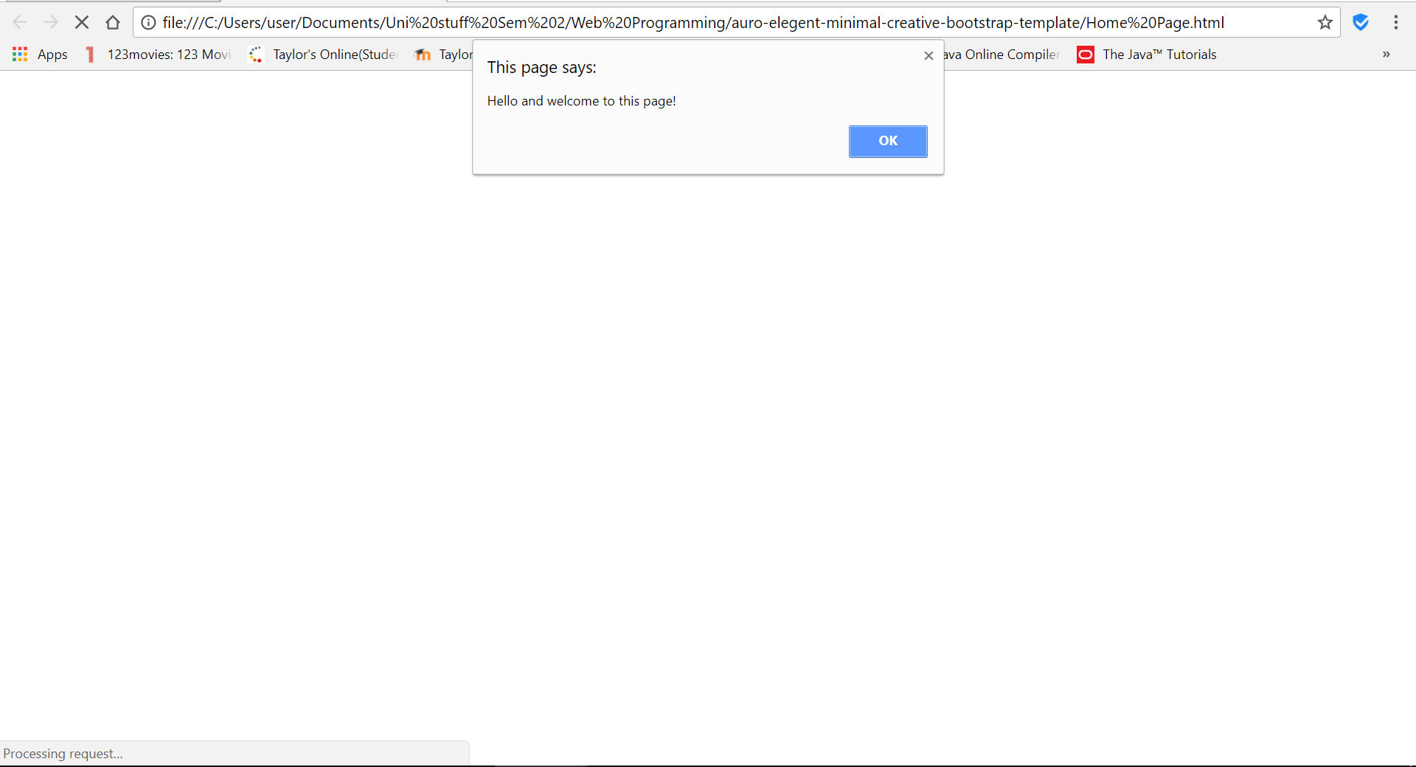

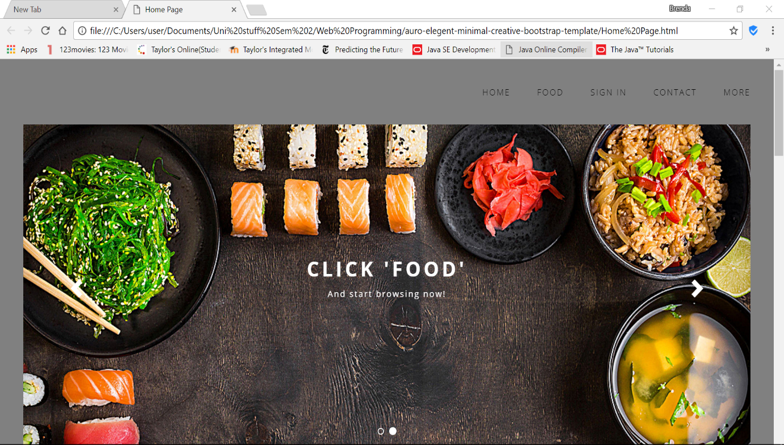

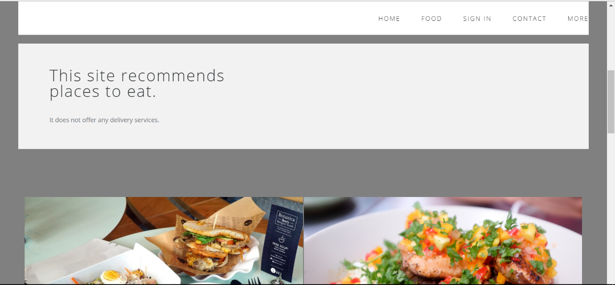

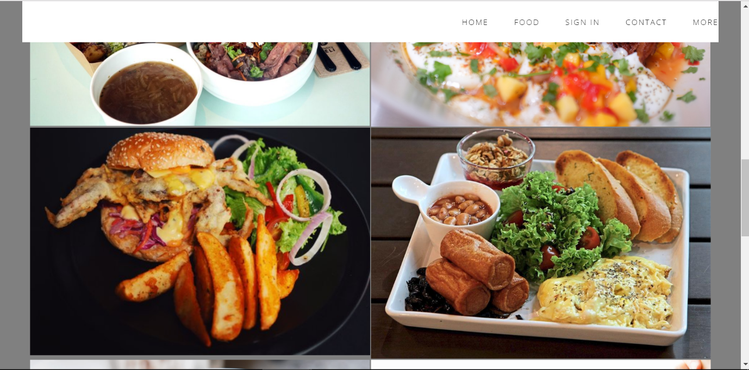

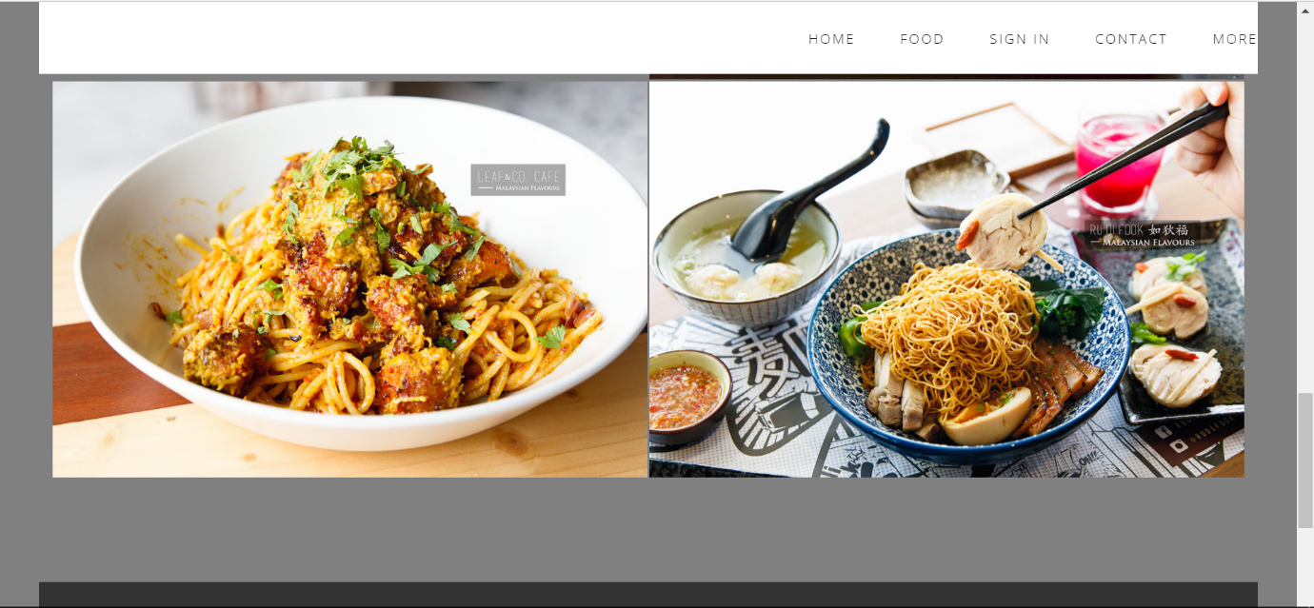

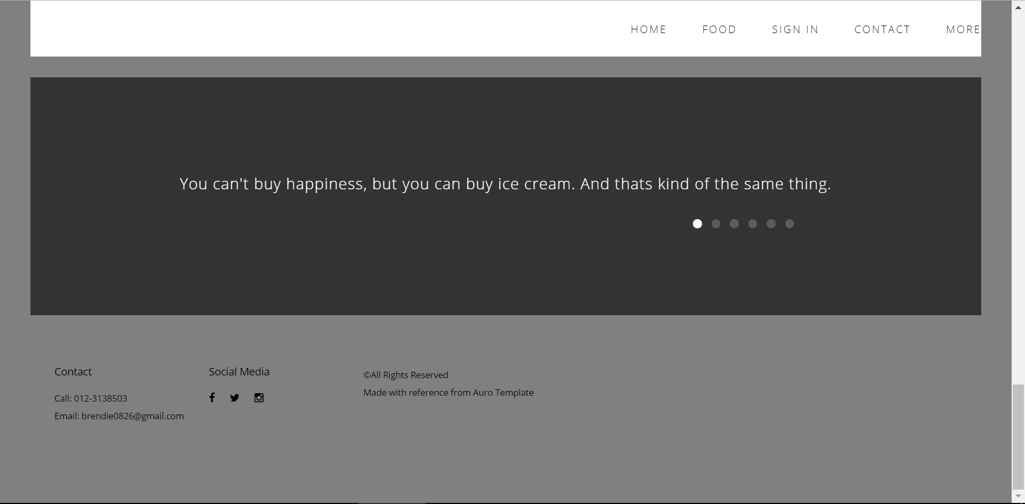

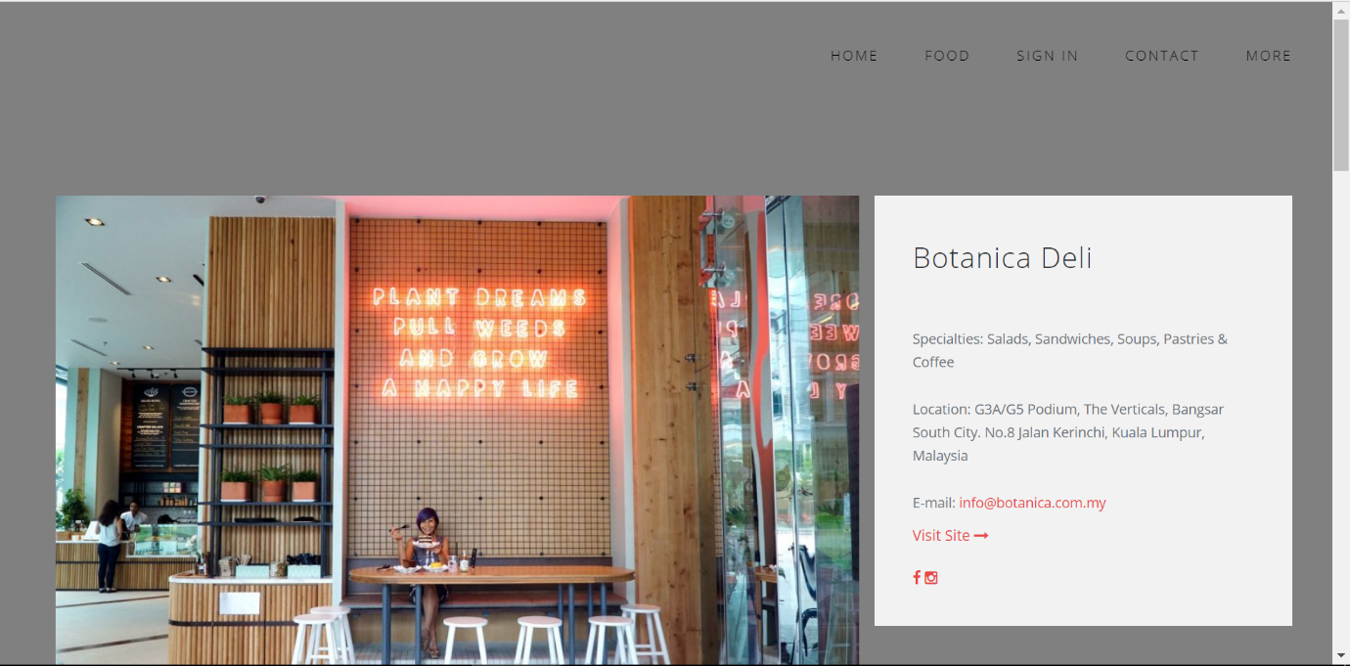

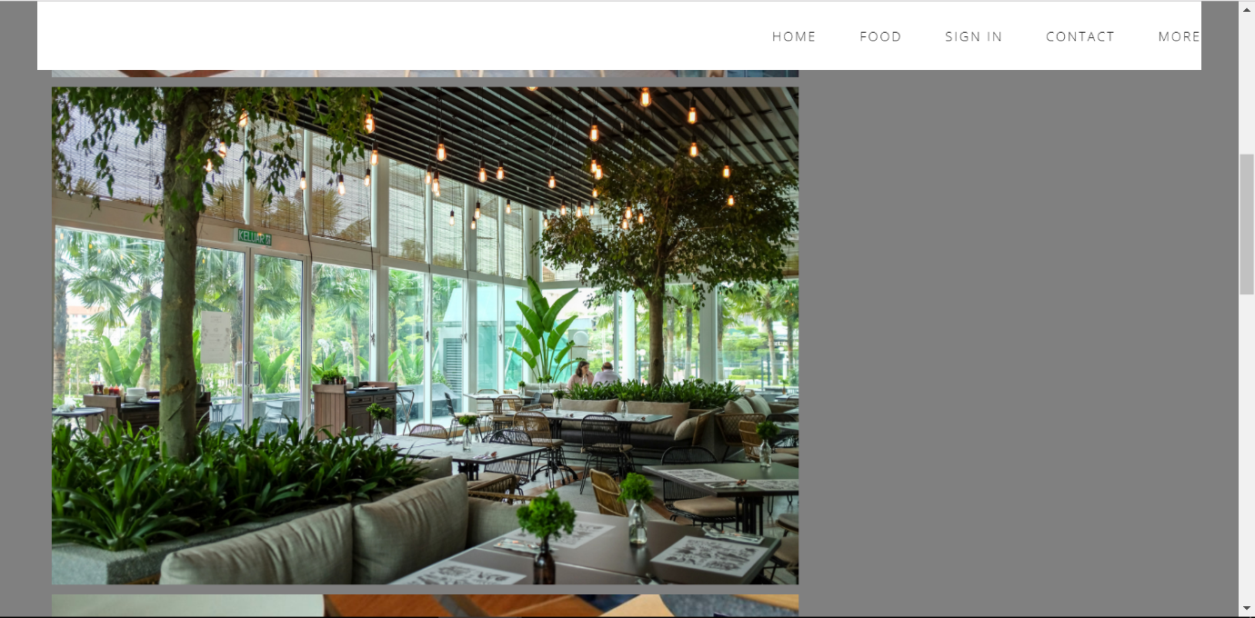

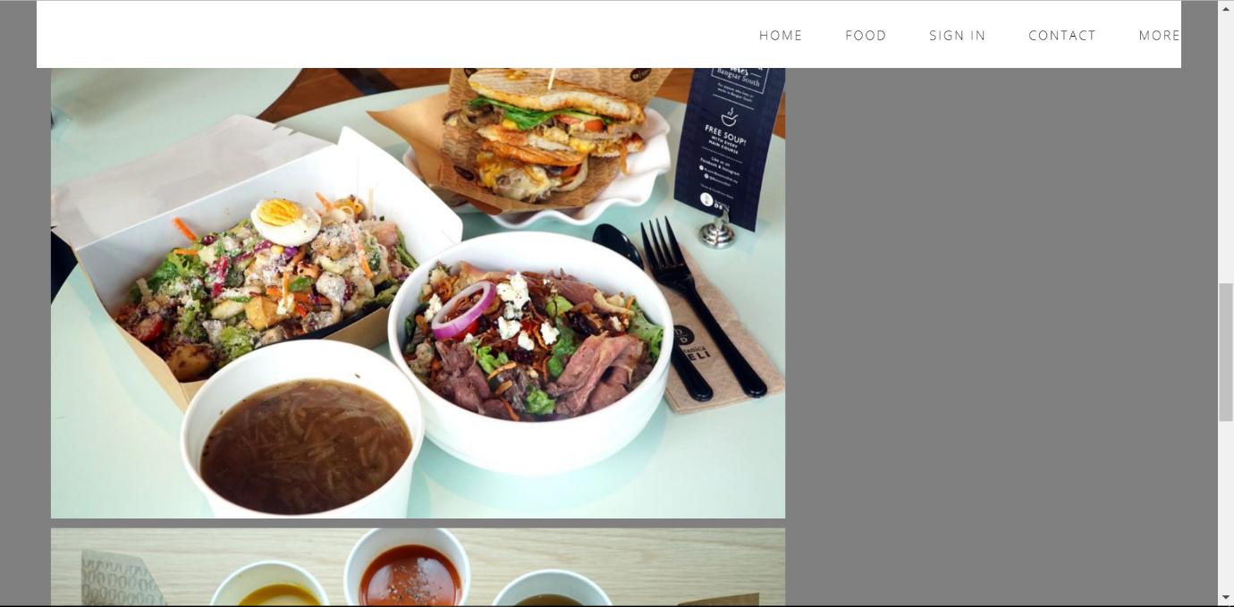

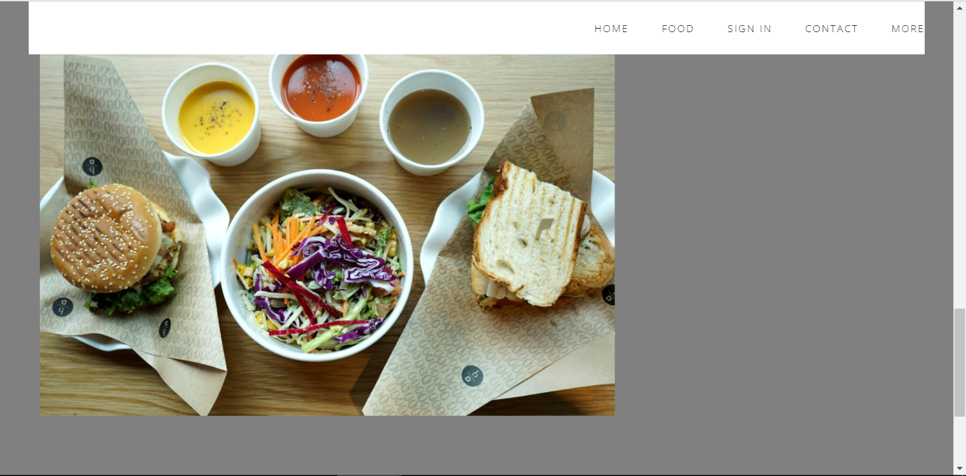

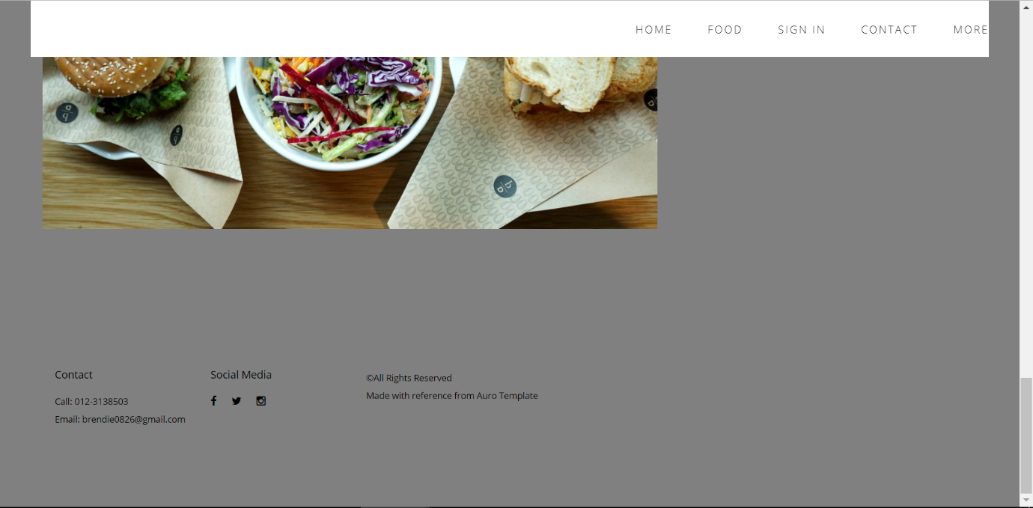

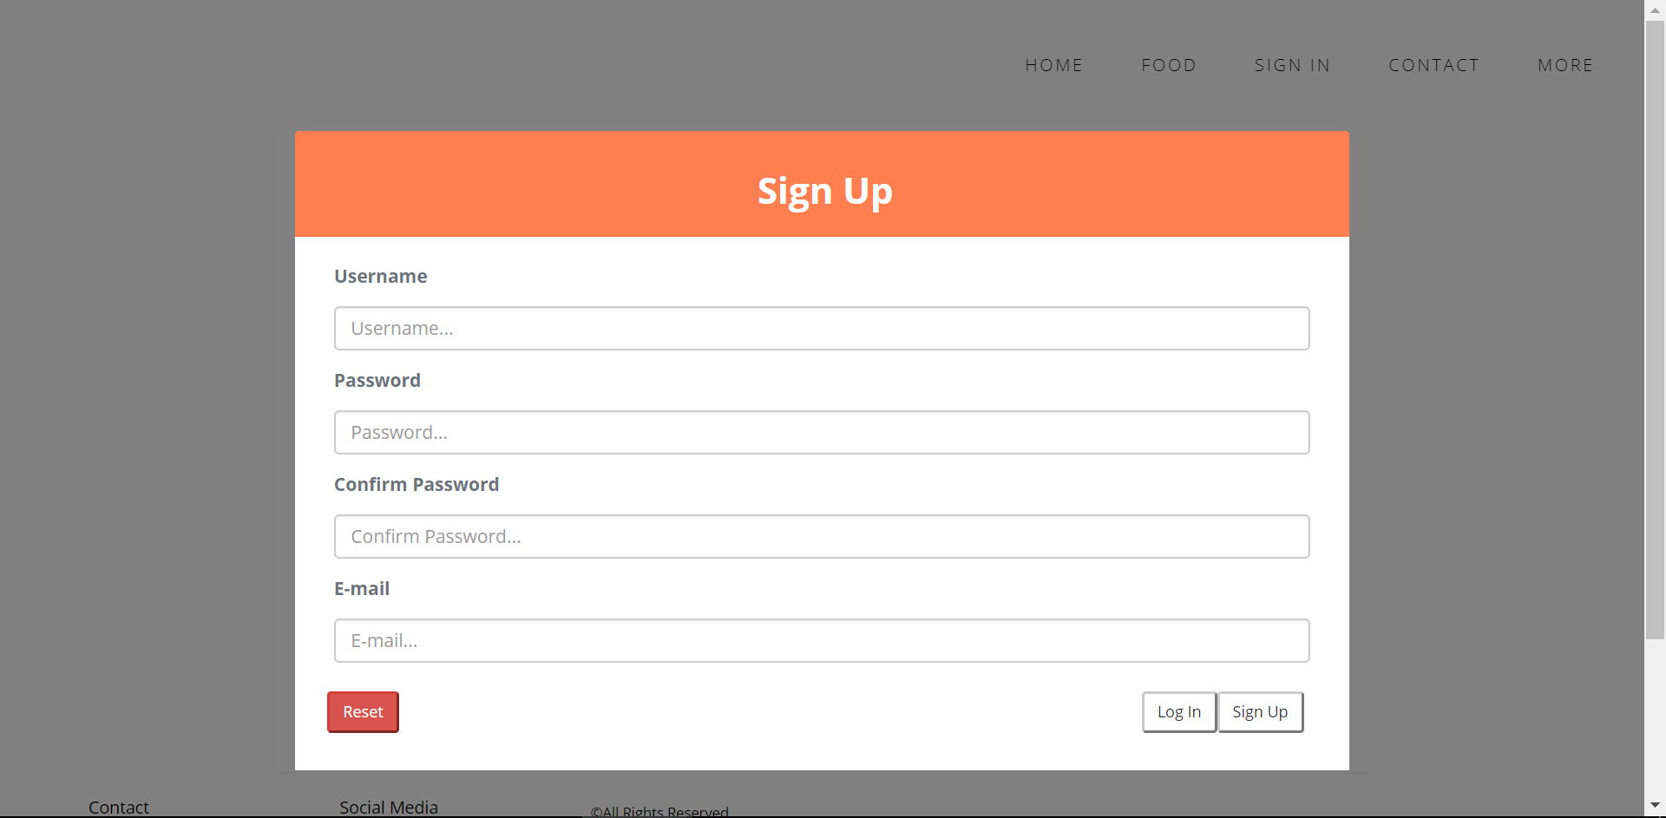

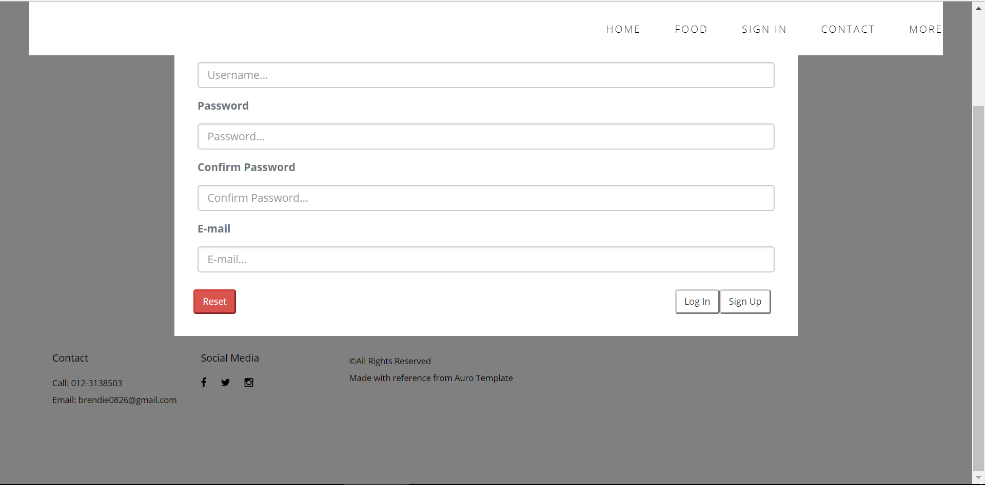

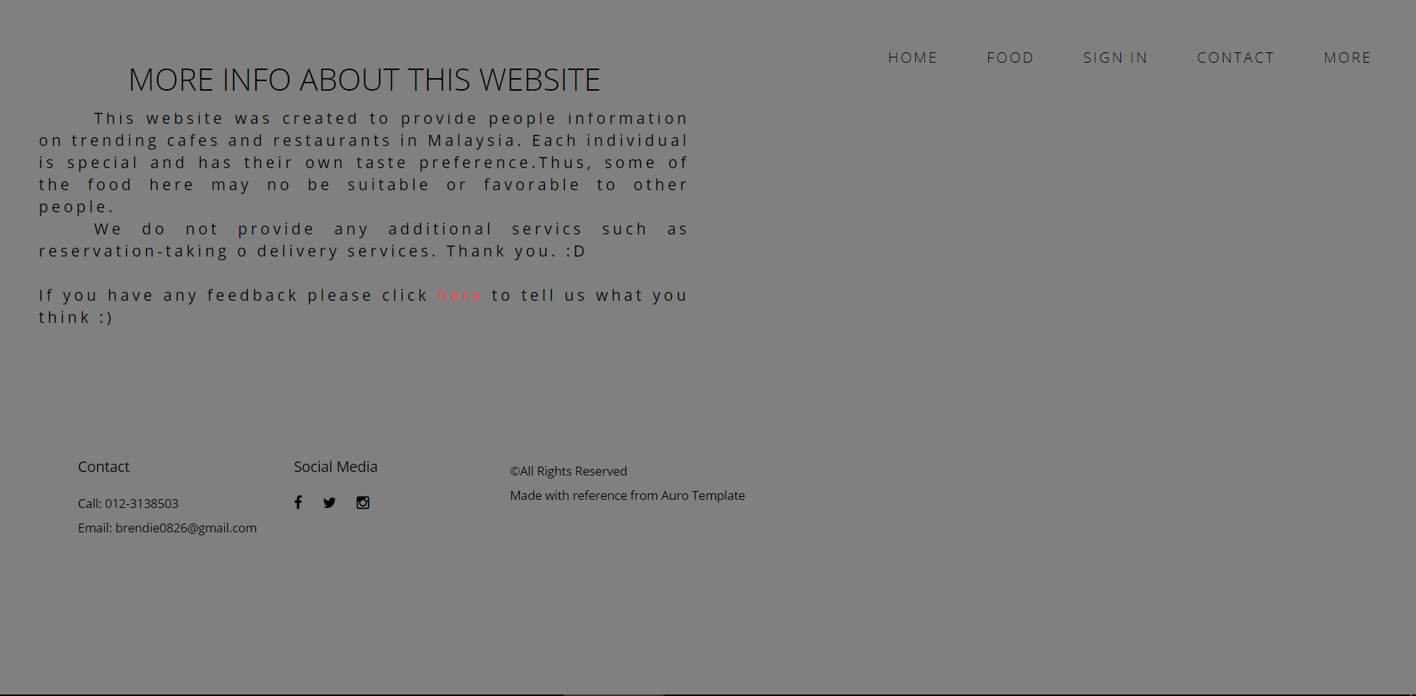

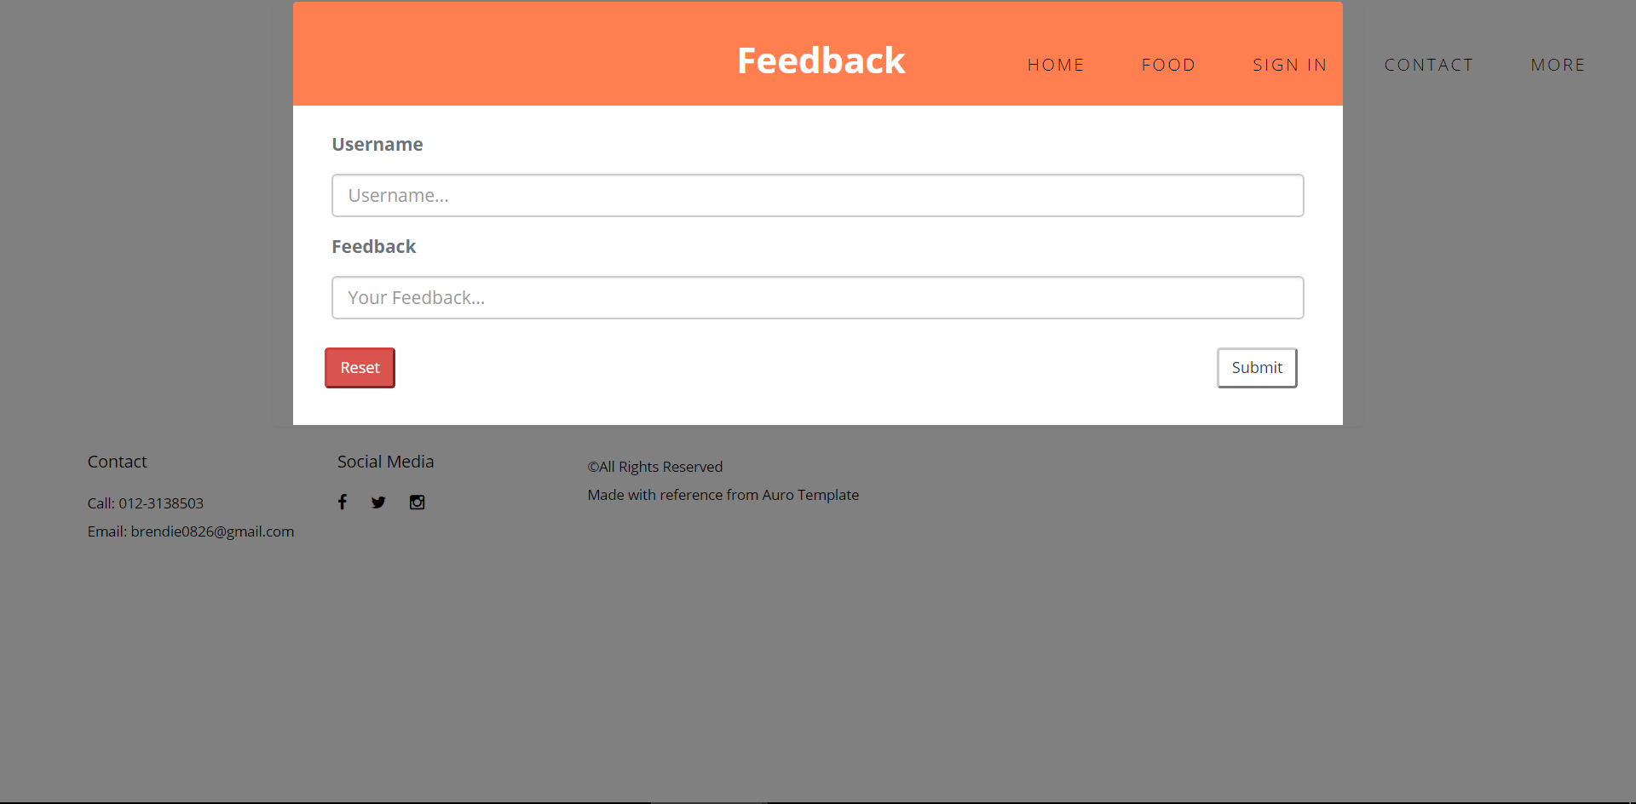

**Source Code**

**Home Page**

<!DOCTYPE html>

<html>

<title>Home Page</title>

<!-- JS FILES -->

<script src="https://ajax.googleapis.com/ajax/libs/jquery/1.11.3/jquery.min.js"></script>

<script src="js/bootstrap.min.js"></script>

<script src="js/jquery.flexslider-min.js"></script>

<script src="js/retina.min.js"></script>

<script src="js/modernizr.js"></script>

<script src="js/main.js"></script>

<head>

<meta charset="utf-8">

<meta name="description" content="">

<meta name="viewport" content="width=device-width, initial-scale=1">

<link rel="stylesheet" href="css/bootstrap.min.css">

<link rel="stylesheet" href="css/flexslider.css">

<link rel="stylesheet" href="css/main.css">

<link rel="stylesheet" href="css/responsive.css">

<link rel="stylesheet" href="css/animate.min.css">

<link rel="stylesheet" href="https://maxcdn.bootstrapcdn.com/font-awesome/4.4.0/css/font-awesome.min.css">

</head>

<style>

body {

background-color: gray;

}

</style>

<script>

alert("Hello and welcome to this page!");

</script>

<body>

<!-- Header Section -->

<section class="tophead" role="tophead">

<!-- Navigation Section -->

<header id="header">

<div class="header-content clearfix">

<nav class="navigation" role="navigation">

<ul class="primary-nav">

<li><a href="#header-slider">Home</a></li>

<li><a href="#recommendation">Food</a></li>

<li><a href="C:\Users\user\Documents\Uni stuff Sem 2\Web Programming\auro-elegent-minimal-creative-bootstrap-template\Sign%20In.html">Sign In</a></li>

<li><a href="#aboutus">Contact</a></li>

<li><a href="C:/Users/user/Documents/Uni%20stuff%20Sem%202/Web%20Programming/auro-elegent-minimal-creative-bootstrap-template/More.html">More</a></li>

</ul>

</nav>

<a href="#" class="nav-toggle"></a> </div>

</header>

<!-- Navigation Section -->

</section>

<!-- Header Section -->

<!-- Slider Section -->

<div id="header-slider" class="section">

<div id="myCarousel" class="carousel slide" data-ride="carousel">

<!-- Indicators -->

<ol class="carousel-indicators">

<li data-target="#myCarousel" data-slide-to="0" class="active"></li>

<li data-target="#myCarousel" data-slide-to="1"></li>

</ol>

<!-- Wrapper for slides -->

<div class="carousel-inner">

<div class="item active">

<img src="https://www.grazia.fr/var/grazia/storage/images/article/l-infographie-du-jour-5-maitres-du-foodporn-a-suivre-sur-instagram-825192/13472691-1-fre-FR/L-infographie-du-jour-5-maitres-du-foodporn-a-suivre-sur-Instagram.jpg" alt="instagram picture">

<div class="carousel-caption">

<h3 style="color: white; text-shadow: 2px 2px 1px #000000">Looking for Insta worthy pictures?</h3>

<p style="color:white; text-shadow: 2px 2px 1px #000000">Browse our gallery for food pictures and more info on where to find them.</p>

</div>

</div>

<div class="item">

<img src="http://bpic.588ku.com/back_pic/03/71/32/8557b7d24061295.jpg" alt="food img">

<div class="carousel-caption">

<h3 style="color:white">Click 'Food'</h3>

<p style="color:white">And start browsing now!</p>

</div>

</div>

</div>

<!-- Left and Right Controls -->

<a class="left carousel-control" href="#myCarousel" data-slide="prev">

<span class="glyphicon glyphicon-chevron-left"></span>

<span class="sr-only">Previous</span>

</a>

<a class="right carousel-control" href="#myCarousel" data-slide="next">

<span class="glyphicon glyphicon-chevron-right"></span>

<span class="sr-only">Next</span>

</a>

</div>

</div>

<!-- Slider Section -->

<!-- Disclaimer -->

<section id="text" class="disclaimer">

<div class="container-fluid">

<div class="row">

<div class="col-md-6 col-sm-6">

<div class="disclaimer-content">

<h4>This site recommends places to eat.</h4>

<p>It does not offer any delivery services.</p>

</div>

</div>

</div>

</div>

</section>

<!-- Recommendation Section -->

<table>

<div id="recommendation" class="section recommendation">

<div class="container-fluid">

<div class="row">

<div class="col-sm-6 recommendation-item">

<a href="file:///C:/Users/user/Documents/Uni%20stuff%20Sem%202/Web%20Programming/auro-elegent-minimal-creative-bootstrap-template/Food(Botanica%20Deli).html" class="recommendation-link">

<div class="caption">

<div class="caption-content">

<h3>Botanica Deli</h3>

</div>

</div>

<img src="http://www.rebeccasaw.com/wp-content/uploads/Botanica-Deli-@-Hotel-VE-Bangsar-South-City-008-1024x716.jpg" class="img-responsive" alt="">

</a>

</div>

<div class="col-sm-6 recommendation-item">

<a href="file:///C:/Users/user/Documents/Uni%20stuff%20Sem%202/Web%20Programming/auro-elegent-minimal-creative-bootstrap-template/Food(Merchant's%20Lane).html" class="recommendation-link">

<div class="caption">

<div class="caption-content">

<h3>Merchant's Lane</h3>

</div>

</div>

<img src="http://2.bp.blogspot.com/-Dz0JqLltJU8/VaJp5LrDwQI/AAAAAAABRCY/khvWTCpaDKk/s1600/DSCF6700-001.jpg" class="img-responsive" alt="">

</a>

</div>

<div class="col-sm-6 recommendation-item">

<a href="file:///C:/Users/user/Documents/Uni%20stuff%20Sem%202/Web%20Programming/auro-elegent-minimal-creative-bootstrap-template/Food(Quartet%20TTDI).html" class="recommendation-link">

<div class="caption">

<div class="caption-content">

<h3>Quartet TTDI</h3>

</div>

</div>

<img style="width:550"; height="388"; src="https://media-cdn.tripadvisor.com/media/photo-s/0e/fd/92/2a/soft-shell-crab-burger.jpg" alt="">

</a>

</div>

<div class="col-sm-6 recommendation-item">

<a href="file:///C:/Users/user/Documents/Uni%20stuff%20Sem%202/Web%20Programming/auro-elegent-minimal-creative-bootstrap-template/Food(Velocity%20Cafe).html#header-slider" class="recommendation-link">

<div class="caption">

<div class="caption-content">

<h3>Velocity Cafe</h3>

</div>

</div>

<img src="http://cdn.star2.com/wp-content/uploads/2016/08/str2_abivelocity_abirami_25.jpg" class="img-responsive" alt="">

</a>

</div>

<div class="col-sm-6 recommendation-item">

<a href="file:///C:/Users/user/Documents/Uni%20stuff%20Sem%202/Web%20Programming/auro-elegent-minimal-creative-bootstrap-template/Food(Leaf&Co).html" class="recommendation-link">

<div class="caption">

<div class="caption-content">

<h3>Leaf & Co</h3>

</div>

</div>

<img src="https://c2.staticflickr.com/9/8520/29129420873_2deed32f43_o.jpg" class="img-responsive" alt="">

</a>

</div>

<div class="col-sm-6 recommendation-item">

<a href="file:///C:/Users/user/Documents/Uni%20stuff%20Sem%202/Web%20Programming/auro-elegent-minimal-creative-bootstrap-template/Food(Ru%20Di%20Fook%20Noodle%20Bar).html" class="recommendation-link">

<div class="caption">

<div class="caption-content">

<h3>Ru Di Fook Noodle Bar</h3>

</div>

</div>

<img src="https://c1.staticflickr.com/3/2895/33393290844_237f0b359c_o.jpg" class="img-responsive" alt="">

</a>

</div>

</div>

</div>

</div>

<!-- Recommendation Section -->

<!-- Quotes Section -->

<section id="quotes" class="section quotes no-padding">

<div class="container-fluid">

<div class="row no-gutter">

<div class="flexslider">

<ul class="slides">

<li>

<div class="col-md-12">

<blockquote>

<h1>You can't buy happiness, but you can buy ice cream. And thats kind of the same thing.</h1>

</blockquote>

</div>

</li>

<li>

<div class="col-md-12">

<blockquote>

<h1>I am not a glutton, I am an explorer of food.</h1>

<p>Erma Bombeck</p>

</blockquote>

</div>

</li>

<li>

<div class="col-md-12">

<blockquote>

<h1>Omm Nom Nom Nom.</h1>

<p>Cookie Monster</p>

</blockquote>

</div>

</li>

<li>

<div class="col-md-12">

<blockquote>

<h1>Hard work should be rewarded by good food.</h1>

<p>Ken Follett</p>

</blockquote>

</div>

</li>

<li>

<div class="col-md-12">

<blockquote>

<h1>There is no love sincerer than the love of food.</h1>

<p>George Bernard Shaw</p>

</blockquote>

</div>

</li>

<li>

<div class="col-md-12">

<blockquote>

<h1>Let food be thy medicine, and medicine be thy food.</h1>

<p>Hippocrates</p>

</blockquote>

</div>

</li>

</ul>

</div>

</div>

</div>

</section>

<!-- Quotes Section -->

<!-- About Us Section -->

<footer id="aboutus" class="footer">

<div class="container-fluid">

<div class="col-md-2 left">

<h4>Contact</h4>

<p> Call: 012-3138503<br>Email:<a href="brendie0826@gmail.com"> brendie0826@gmail.com </a></p>

</div>

<div class="col-md-2 left">

<h4>Social Media</h4>

<ul class="footer-share">

<li>

<a href="https://www.google.com/search?q=facebook+login&rlz=1C1CHBF_enMY767MY768&oq=facbook+lo&aqs=chrome.2.69i57j0l5.4907j0j7&sourceid=chrome&ie=UTF-8">

<i class="fa fa-facebook"></i>

</a>

</li>

<li>

<a href="https://twitter.com/login">

<i class="fa fa-twitter"></i>

</a>

</li>

<li>

<a href="https://www.instagram.com/accounts/login/">

<i class="fa fa-instagram"></i>

</a>

</li>

</ul>

</div>

<div class="col-md-6 right">

<p>©All Rights Reserved<br>Made with reference from <a href="http://designstub.com/demos/auro/">Auro Template</a></p>

</div>

</div>

</footer>

<!-- About Us Section -->

</body>

</html>

**Food1 page**

<!DOCTYPE html>

<html>

<title>Botanica Deli</title>

<!-- JS FILES -->

<script src="https://ajax.googleapis.com/ajax/libs/jquery/1.11.3/jquery.min.js"></script>

<script src="js/bootstrap.min.js"></script>

<script src="js/jquery.flexslider-min.js"></script>

<script src="js/retina.min.js"></script>

<script src="js/modernizr.js"></script>

<script src="js/main.js"></script>

<head>

<meta charset="utf-8">

<meta name="description" content="">

<meta name="viewport" content="width=device-width, initial-scale=1">

<link rel="stylesheet" href="css/bootstrap.min.css">

<link rel="stylesheet" href="css/flexslider.css">

<link rel="stylesheet" href="css/main.css">

<link rel="stylesheet" href="css/responsive.css">

<link rel="stylesheet" href="css/animate.min.css">

<link rel="stylesheet" href="https://maxcdn.bootstrapcdn.com/font-awesome/4.4.0/css/font-awesome.min.css">

</head>

<style>

body {

background:gray;

}

</style>

<body>

<!-- Header Section -->

<div class="tophead" role="tophead">

<!-- Navigation Section -->

<header id="header">

<div class="header-content clearfix">

<nav class="navigation" role="navigation">

<ul class="primary-nav">

<li><a href="file:///C:/Users/user/Documents/Uni%20stuff%20Sem%202/Web%20Programming/auro-elegent-minimal-creative-bootstrap-template/Home%20Page.html">Home</a></li>

<li><a href="#recommendation">Food</a></li>

<li><a href="C:\Users\user\Documents\Uni stuff Sem 2\Web Programming\auro-elegent-minimal-creative-bootstrap-template\Sign%20In.html">Sign In</a></li>

<li><a href="#aboutus">Contact</a></li>

<li><a href="C:/Users/user/Documents/Uni%20stuff%20Sem%202/Web%20Programming/auro-elegent-minimal-creative-bootstrap-template/More.html">More</a></li>

</ul>

</nav>

<a href="#" class="nav-toggle"></a> </div>

</header>

<!-- Navigation Section -->

</div>

<!-- Header Section -->

<!-- Details section -->

<div id="bddetail" class="section detail">

<div class="container-fluid">

<div class="row">

<div class="col-md-8 detail-margin detail-image">

<div class="image">

<p><img src="http://www.rebeccasaw.com/wp-content/uploads/Botanica-Deli-@-Hotel-VE-Bangsar-South-City-015-1024x682.jpg"></p>

<p><img src="https://1.bp.blogspot.com/-wSSGliHAiWw/V2U3ohNTlBI/AAAAAAABhgk/NkMgW3kRjRQLaY9KVtZd9d1ETqa5KWgxgCLcB/s1600/DSCF5510-001.jpg"></p>

<p><img src="http://www.rebeccasaw.com/wp-content/uploads/Botanica-Deli-@-Hotel-VE-Bangsar-South-City-008-1024x716.jpg"></p>

<p><img src="http://q-e3.com/wp/wp-content/uploads/2016/07/botanica-deli-feature-image-BIG.jpg"></p>

</div>

</div>

<div class="col-md-4 detail-margin detail-contentbox">

<div class="detail-content">

<h4>Botanica Deli</h4>

<br>

<p>Specialties: Salads, Sandwiches, Soups, Pastries & Coffee</p>

<p>Location: G3A/G5 Podium, The Verticals, Bangsar South City. No.8 Jalan Kerinchi, Kuala Lumpur, Malaysia</p>

<p>E-mail: <a href="info@botanica.com.my">info@botanica.com.my</a></p>

<a class="button" href="http://www.botanica.com.my/deli/">Visit Site <i class="fa fa-long-arrow-right"></i></a> </div>

<br>

<a href="https://www.facebook.com/BotanicaDeli.my/">

<i class="fa fa-facebook"></i>

</a>

<a href="https://www.instagram.com/botanicadeli/">

<i class="fa fa-instagram"></i>

</a>

</div>

</div>

</div>

</div>

<!-- About Us Section -->

<footer id="aboutus" class="footer">

<div class="container-fluid">

<div class="col-md-2 left">

<h4>Contact</h4>

<p> Call: 012-3138503<br>Email:<a href="brendie0826@gmail.com"> brendie0826@gmail.com </a></p>

</div>

<div class="col-md-2 left">

<h4>Social Media</h4>

<ul class="footer-share">

<li>

<a href="https://www.google.com/search?q=facebook+login&rlz=1C1CHBF_enMY767MY768&oq=facbook+lo&aqs=chrome.2.69i57j0l5.4907j0j7&sourceid=chrome&ie=UTF-8">

<i class="fa fa-facebook"></i>

</a>

</li>

<li>

<a href="https://twitter.com/login">

<i class="fa fa-twitter"></i>

</a>

</li>

<li>

<a href="https://www.instagram.com/accounts/login/">

<i class="fa fa-instagram"></i>

</a>

</li>

</ul>

</div>

<div class="col-md-6 right">

<p>©All Rights Reserved<br>Made with reference from <a href="http://designstub.com/demos/auro/">Auro Template</a></p>

</div>

</div>

</footer>

<!-- About Us Section -->

</body>

</html>

**Food2 Page**

<!DOCTYPE html>

<html>

<title>Merchant's Lane</title>

<!-- JS FILES -->

<script src="https://ajax.googleapis.com/ajax/libs/jquery/1.11.3/jquery.min.js"></script>

<script src="js/bootstrap.min.js"></script>

<script src="js/jquery.flexslider-min.js"></script>

<script src="js/retina.min.js"></script>

<script src="js/modernizr.js"></script>

<script src="js/main.js"></script>

<head>

<meta charset="utf-8">

<meta name="description" content="">

<meta name="viewport" content="width=device-width, initial-scale=1">

<link rel="stylesheet" href="css/bootstrap.min.css">

<link rel="stylesheet" href="css/flexslider.css">

<link rel="stylesheet" href="css/main.css">

<link rel="stylesheet" href="css/responsive.css">

<link rel="stylesheet" href="css/animate.min.css">

<link rel="stylesheet" href="https://maxcdn.bootstrapcdn.com/font-awesome/4.4.0/css/font-awesome.min.css">

</head>

<style>

body {

background:gray;

}

</style>

<body>

<!-- Header Section -->

<section class="tophead" role="tophead">

<!-- Navigation Section -->

<header id="header">

<div class="header-content clearfix">

<nav class="navigation" role="navigation">

<ul class="primary-nav">

<li><a href="file:///C:/Users/user/Documents/Uni%20stuff%20Sem%202/Web%20Programming/auro-elegent-minimal-creative-bootstrap-template/Home%20Page.html">Home</a></li>

<li><a href="#food">Food</a></li>

<li><a href="C:\Users\user\Documents\Uni stuff Sem 2\Web Programming\auro-elegent-minimal-creative-bootstrap-template\Sign%20In.html">Sign In</a></li>

<li><a href="#aboutus">Contact</a></li>

<li><a href="C:/Users/user/Documents/Uni%20stuff%20Sem%202/Web%20Programming/auro-elegent-minimal-creative-bootstrap-template/More.html">More</a></li>

</ul>

</nav>

<a href="#" class="nav-toggle"></a> </div>

</header>

<!-- Navigation Section -->

</section>

<!-- Header Section -->

<!-- Details section -->

<div id="mldetail" class="section detail">

<div class="container-fluid">

<div class="row">

<div class="col-md-8 detail-margin detail-image">

<div class="image">

<p><img src="http://www.powideas.co/wp-content/uploads/2017/05/Merchants-Hi-Res.jpg"></p>

<p><img src="http://vmo.rocks/wp-content/uploads//2016/12/merchants_lane_01-cc3be3cec6afb405cb5f98e161a7e269.jpg"></p>

<p><img src="http://www.bangsarbabe.com/wp-content/uploads/2017/03/P1100279a-1600x700_1.jpg"></p>

<p><img src="http://poskod.my/wp-content/uploads/2015/10/IMG_8147.jpg"></p>

</div>

</div>

<div class="col-md-4 detail-margin detail-contentbox">

<div class="detail-content">

<h4>Merchant's Lane 美真林</h4>

<br>

<p>Specialties: Breakfast， Brunch & Coffee</p>

<p>Location: No, 150 Jalan Petaling， Kuala Lumpur, Malaysia</p>

<p>E-mail: <a href="merchantslane@gmail.com">merchantslane@gmail.com</a></p>

<br>

<a href="https://www.facebook.com/merchantslane/">

<i class="fa fa-facebook"></i>

</a>

<a href="https://www.instagram.com/merchantslane/">

<i class="fa fa-instagram"></i>

</a>

</div>

</div>

</div>

</div>

<!-- About Us Section -->

<footer id="aboutus" class="footer">

<div class="container-fluid">

<div class="col-md-2 left">

<h4>Contact</h4>

<p> Call: 012-3138503<br>Email:<a href="brendie0826@gmail.com"> brendie0826@gmail.com </a></p>

</div>

<div class="col-md-2 left">

<h4>Social Media</h4>

<ul class="footer-share">

<li>

<a href="https://www.google.com/search?q=facebook+login&rlz=1C1CHBF_enMY767MY768&oq=facbook+lo&aqs=chrome.2.69i57j0l5.4907j0j7&sourceid=chrome&ie=UTF-8">

<i class="fa fa-facebook"></i>

</a>

</li>

<li>

<a href="https://twitter.com/login">

<i class="fa fa-twitter"></i>

</a>

</li>

<li>

<a href="https://www.instagram.com/accounts/login/">

<i class="fa fa-instagram"></i>

</a>

</li>

</ul>

</div>

<div class="col-md-6 right">

<p>©All Rights Reserved<br>Made with reference from <a href="http://designstub.com/demos/auro/">Auro Template</a></p>

</div>

</div>

</footer>

<!-- About Us Section -->

</body>

</html>

</html>

**Food3 Page**

<!DOCTYPE html>

<html>

<title>Quartet TTDI</title>

<!-- JS FILES -->

<script src="https://ajax.googleapis.com/ajax/libs/jquery/1.11.3/jquery.min.js"></script>

<script src="js/bootstrap.min.js"></script>

<script src="js/jquery.flexslider-min.js"></script>

<script src="js/retina.min.js"></script>

<script src="js/modernizr.js"></script>

<script src="js/main.js"></script>

<head>

<meta charset="utf-8">

<meta name="description" content="">

<meta name="viewport" content="width=device-width, initial-scale=1">

<link rel="stylesheet" href="css/bootstrap.min.css">

<link rel="stylesheet" href="css/flexslider.css">

<link rel="stylesheet" href="css/main.css">

<link rel="stylesheet" href="css/responsive.css">

<link rel="stylesheet" href="css/animate.min.css">

<link rel="stylesheet" href="https://maxcdn.bootstrapcdn.com/font-awesome/4.4.0/css/font-awesome.min.css">

</head>

<style>

body {

background:gray;

}

</style>

<body>

<!-- Header Section -->

<section class="tophead" role="tophead">

<!-- Navigation Section -->

<header id="header">

<div class="header-content clearfix">

<nav class="navigation" role="navigation">

<ul class="primary-nav">

<li><a href="file:///C:/Users/user/Documents/Uni%20stuff%20Sem%202/Web%20Programming/auro-elegent-minimal-creative-bootstrap-template/Home%20Page.html">Home</a></li>

<li><a href="#food">Food</a></li>

<li><a href="C:\Users\user\Documents\Uni stuff Sem 2\Web Programming\auro-elegent-minimal-creative-bootstrap-template\Sign%20In.html">Sign In</a></li>

<li><a href="#aboutus">Contact</a></li>

<li><a href="C:/Users/user/Documents/Uni%20stuff%20Sem%202/Web%20Programming/auro-elegent-minimal-creative-bootstrap-template/More.html">More</a></li>

</ul>

</nav>

<a href="#" class="nav-toggle"></a> </div>

</header>

<!-- Navigation Section -->

</section>

<!-- Header Section -->

<!-- Details section -->

<section id="qtdetail" class="section detail">

<div class="container-fluid">

<div class="row">

<div class="col-md-8 detail-margin detail-image">

<div class="image">

<p><img src="http://2.bp.blogspot.com/--4XW7oHJGBw/VSvlRL8mSTI/AAAAAAAAGfY/hxJK_UtrJ00/s1600/DSC04312.JPG"></p>

<p><img src="http://2.bp.blogspot.com/-fjC8rSe22EQ/U6BLcFpB4MI/AAAAAAAActk/QoOZYN75Uzc/s1600/quartet5.jpg"></p>

<p><img src="http://2.bp.blogspot.com/-rtmKHdjJR64/VN38o8M5L6I/AAAAAAABJlw/bCzwf_FmoYo/s1600/DSCF0002-001.jpg"></p>

<p><img src="http://1.bp.blogspot.com/-QvZdOsafPo8/UonH5QPejII/AAAAAAAAHD4/b6P6dtwsz9M/s1600/R0023560+copy.JPG"></p>

</div>

</div>

<div class="col-md-4 detail-margin detail-contentbox">

<div class="detail-content">

<h4>Quartet TTDI</h4>

<br>

<p>Specialties: Breakfast Lunch Coffee & Drinks</p>

<p>Location: 21, Lorong Datuk Sulaiman 7, Taman Tun Dr Ismail, Kuala Lumpur, Malaysia</p>

<p>E-mail: <a href="hellottdi@quartet-kl.co">hellottdi@quartet-kl.co</a></p>

<br>

<a href="https://www.facebook.com/quartetttdi/">

<i class="fa fa-facebook"></i>

</a>

<a href="https://twitter.com/quartetttdi">

<i class="fa fa-twitter"></i>

</a>

</div>

</div>

</div>

</section>

<!-- About Us Section -->

<footer id="aboutus" class="footer">

<div class="container-fluid">

<div class="col-md-2 left">

<h4>Contact</h4>

<p> Call: 012-3138503<br>Email:<a href="brendie0826@gmail.com"> brendie0826@gmail.com </a></p>

</div>

<div class="col-md-2 left">

<h4>Social Media</h4>

<ul class="footer-share">

<li>

<a href="https://www.google.com/search?q=facebook+login&rlz=1C1CHBF_enMY767MY768&oq=facbook+lo&aqs=chrome.2.69i57j0l5.4907j0j7&sourceid=chrome&ie=UTF-8">

<i class="fa fa-facebook"></i>

</a>

</li>

<li>

<a href="https://twitter.com/login">

<i class="fa fa-twitter"></i>

</a>

</li>

<li>

<a href="https://www.instagram.com/accounts/login/">

<i class="fa fa-instagram"></i>

</a>

</li>

</ul>

</div>

<div class="col-md-6 right">

<p>©All Rights Reserved<br>Made with reference from <a href="http://designstub.com/demos/auro/">Auro Template</a></p>

</div>

</div>

</footer>

<!-- About Us Section -->

</body>

</html>

</html>

**Food4 Page**

<!DOCTYPE html>

<html>

<title>Velocity Cafe</title>

<!-- JS FILES -->

<script src="https://ajax.googleapis.com/ajax/libs/jquery/1.11.3/jquery.min.js"></script>

<script src="js/bootstrap.min.js"></script>

<script src="js/jquery.flexslider-min.js"></script>

<script src="js/retina.min.js"></script>

<script src="js/modernizr.js"></script>

<script src="js/main.js"></script>

<head>

<meta charset="utf-8">

<meta name="description" content="">

<meta name="viewport" content="width=device-width, initial-scale=1">

<link rel="stylesheet" href="css/bootstrap.min.css">

<link rel="stylesheet" href="css/flexslider.css">

<link rel="stylesheet" href="css/main.css">

<link rel="stylesheet" href="css/responsive.css">

<link rel="stylesheet" href="css/animate.min.css">

<link rel="stylesheet" href="https://maxcdn.bootstrapcdn.com/font-awesome/4.4.0/css/font-awesome.min.css">

</head>

<style>

body {

background:gray;

}

</style>

<body>

<!-- Header Section -->

<section class="tophead" role="tophead">

<!-- Navigation Section -->

<header id="header">

<div class="header-content clearfix">

<nav class="navigation" role="navigation">

<ul class="primary-nav">

<li><a href="file:///C:/Users/user/Documents/Uni%20stuff%20Sem%202/Web%20Programming/auro-elegent-minimal-creative-bootstrap-template/Home%20Page.html">Home</a></li>

<li><a href="#food">Food</a></li>

<li><a href="C:\Users\user\Documents\Uni stuff Sem 2\Web Programming\auro-elegent-minimal-creative-bootstrap-template\Sign%20In.html">Sign In</a></li>

<li><a href="#aboutus">Contact</a></li>

<li><a href="C:/Users/user/Documents/Uni%20stuff%20Sem%202/Web%20Programming/auro-elegent-minimal-creative-bootstrap-template/More.html">More</a></li>

</ul>

</nav>

<a href="#" class="nav-toggle"></a> </div>

</header>

<!-- Navigation Section -->

</section>

<!-- Header Section -->

<!-- Details section -->

<section id="vcdetail" class="section detail">

<div class="container-fluid">

<div class="row">

<div class="col-md-8 detail-margin detail-image">

<div class="image">

<p><img src="http://cdn.star2.com/wp-content/uploads/2016/08/str2_abivelocity_abirami_1_MAINPIC.jpg"></p>

<p><img src="http://i.hungrygowhere.com/rnr/food-my/39668/2b0d0900/e4c94fc0609118390b0a35064c50105b_1439395689.jpg"></p>

<p><img src="http://cdn.star2.com/wp-content/uploads/2016/08/str2_abivelocity_abirami_10.jpg"></p>

<p><img src="http://images.says.com/uploads/story_source/source_image/554959/a4ec.jpg"></p>

</div>

</div>

<div class="col-md-4 detail-margin detail-contentbox">

<div class="detail-content">

<h4>Velocity Cafe Ampang . Bicycle Workshop & Showroom</h4>

<br>

<p>Specialties: Breakfast, Lunch, Dinner, Coffee & Drinks</p>

<p>Location: Kompleks Destar Arena (Challenger Sports Center, opposite Aeon Big Ampang), Ampang, Kuala Lumpur</p>

<p>E-mail: <a href="myteamvelocity@gmail.com">myteamvelocity@gmail.com</a></p>

<br>

<a href="https://www.facebook.com/VelocityMY/">

<i class="fa fa-facebook"></i>

</a>

<a href="https://www.instagram.com/myteamvelocity/">

<i class="fa fa-instagram"></i>

</a>

</div>

</div>

</div>

</section>

<!-- About Us Section -->

<footer id="aboutus" class="footer">

<div class="container-fluid">

<div class="col-md-2 left">

<h4>Contact</h4>

<p> Call: 012-3138503<br>Email:<a href="brendie0826@gmail.com"> brendie0826@gmail.com </a></p>

</div>

<div class="col-md-2 left">

<h4>Social Media</h4>

<ul class="footer-share">

<li>

<a href="https://www.google.com/search?q=facebook+login&rlz=1C1CHBF_enMY767MY768&oq=facbook+lo&aqs=chrome.2.69i57j0l5.4907j0j7&sourceid=chrome&ie=UTF-8">

<i class="fa fa-facebook"></i>

</a>

</li>

<li>

<a href="https://twitter.com/login">

<i class="fa fa-twitter"></i>

</a>

</li>

<li>

<a href="https://www.instagram.com/accounts/login/">

<i class="fa fa-instagram"></i>

</a>

</li>

</ul>

</div>

<div class="col-md-6 right">

<p>©All Rights Reserved<br>Made with reference from <a href="http://designstub.com/demos/auro/">Auro Template</a></p>

</div>

</div>

</footer>

<!-- About Us Section -->

</body>

</html>

</html>

**Food5 Page**

<!DOCTYPE html>

<html>

<title>Leaf & Co</title>

<!-- JS FILES -->

<script src="https://ajax.googleapis.com/ajax/libs/jquery/1.11.3/jquery.min.js"></script>

<script src="js/bootstrap.min.js"></script>

<script src="js/jquery.flexslider-min.js"></script>

<script src="js/retina.min.js"></script>

<script src="js/modernizr.js"></script>

<script src="js/main.js"></script>

<head>

<meta charset="utf-8">

<meta name="description" content="">

<meta name="viewport" content="width=device-width, initial-scale=1">

<link rel="stylesheet" href="css/bootstrap.min.css">

<link rel="stylesheet" href="css/flexslider.css">

<link rel="stylesheet" href="css/main.css">

<link rel="stylesheet" href="css/responsive.css">

<link rel="stylesheet" href="css/animate.min.css">

<link rel="stylesheet" href="https://maxcdn.bootstrapcdn.com/font-awesome/4.4.0/css/font-awesome.min.css">

</head>

<style>

body {

background:gray;

}

</style>

<body>

<!-- Header Section -->

<div class="tophead" role="tophead">

<!-- Navigation Section -->

<header id="header">

<div class="header-content clearfix">

<nav class="navigation" role="navigation">

<ul class="primary-nav">

<li><a href="file:///C:/Users/user/Documents/Uni%20stuff%20Sem%202/Web%20Programming/auro-elegent-minimal-creative-bootstrap-template/Home%20Page.html">Home</a></li>

<li><a href="#food">Food</a></li>

<li><a href="C:\Users\user\Documents\Uni stuff Sem 2\Web Programming\auro-elegent-minimal-creative-bootstrap-template\Sign%20In.html">Sign In</a></li>

<li><a href="#aboutus">Contact</a></li>

<li><a href="C:/Users/user/Documents/Uni%20stuff%20Sem%202/Web%20Programming/auro-elegent-minimal-creative-bootstrap-template/More.html">More</a></li>

</ul>

</nav>

<a href="#" class="nav-toggle"></a> </div>

</header>

<!-- Navigation Section -->

</div>

<!-- Header Section -->

<!-- Details section -->

<section id="lncdetail" class="section detail">

<div class="container-fluid">

<div class="row">

<div class="col-md-8 detail-margin detail-image">

<div class="image">

<p><img src="http://c1.staticflickr.com/8/7523/29128662024_88702a1fda_o.jpg"></p>

<p><img src="https://3.bp.blogspot.com/-OjUGu-SaMjQ/V81MqSdu7NI/AAAAAAABkQY/w85F6wc6saUiEKgWEIszgBPglP5QnLkwQCLcB/s1600/DSCF0978-001.jpg"></p>

<p><img src="https://c4.staticflickr.com/9/8326/29129205043_ab371ab52b_o.jpg"></p>

<p><img src="https://3.bp.blogspot.com/-qpacO-lgtlo/WMV3retfGGI/AAAAAAAAKiI/MfAvH8Yr8vQRsEQ6YXYgzFI35gKDlNP9ACLcB/s1600/leaf-co-jalan-sultan-kl-cafe-5.jpg"></p>

</div>

</div>

<div class="col-md-4 detail-margin detail-contentbox">

<div class="detail-content">

<h4>leaf & co. cafe</h4>

<br>

<p>Specialties: Breakfast, Lunch, Dinner, Coffee & Drinks</p>

<p>Location: 53, Jalan Sultan, Kuala Lumpur, Malaysia</p>

<br>

<a href="https://www.facebook.com/leafandcocafe/">

<i class="fa fa-facebook"></i>

</a>

</div>

</div>

</div>

</section>

<!-- About Us Section -->

<footer id="aboutus" class="footer">

<div class="container-fluid">

<div class="col-md-2 left">

<h4>Contact</h4>

<p> Call: 012-3138503<br>Email:<a href="brendie0826@gmail.com"> brendie0826@gmail.com </a></p>

</div>

<div class="col-md-2 left">

<h4>Social Media</h4>

<ul class="footer-share">

<li>

<a href="https://www.google.com/search?q=facebook+login&rlz=1C1CHBF_enMY767MY768&oq=facbook+lo&aqs=chrome.2.69i57j0l5.4907j0j7&sourceid=chrome&ie=UTF-8">

<i class="fa fa-facebook"></i>

</a>

</li>

<li>

<a href="https://twitter.com/login">

<i class="fa fa-twitter"></i>

</a>

</li>

<li>

<a href="https://www.instagram.com/accounts/login/">

<i class="fa fa-instagram"></i>

</a>

</li>

</ul>

</div>

<div class="col-md-6 right">

<p>©All Rights Reserved<br>Made with reference from <a href="http://designstub.com/demos/auro/">Auro Template</a></p>

</div>

</div>

</footer>

<!-- About Us Section -->

</body>

</html>

</html>

**Food6 Page**

<!DOCTYPE html>

<html>

<title>Ru Di Fook Noodle Bar</title>

<!-- JS FILES -->

<script src="https://ajax.googleapis.com/ajax/libs/jquery/1.11.3/jquery.min.js"></script>

<script src="js/bootstrap.min.js"></script>

<script src="js/jquery.flexslider-min.js"></script>

<script src="js/retina.min.js"></script>

<script src="js/modernizr.js"></script>

<script src="js/main.js"></script>

<head>

<meta charset="utf-8">

<meta name="description" content="">

<meta name="viewport" content="width=device-width, initial-scale=1">

<link rel="stylesheet" href="css/bootstrap.min.css">

<link rel="stylesheet" href="css/flexslider.css">

<link rel="stylesheet" href="css/main.css">

<link rel="stylesheet" href="css/responsive.css">

<link rel="stylesheet" href="css/animate.min.css">

<link rel="stylesheet" href="https://maxcdn.bootstrapcdn.com/font-awesome/4.4.0/css/font-awesome.min.css">

</head>

<style>

body {

background:gray;

}

</style>

<body>

<!-- Header Section -->

<section class="tophead" role="tophead">

<!-- Navigation Section -->

<header id="header">

<div class="header-content clearfix">

<nav class="navigation" role="navigation">

<ul class="primary-nav">

<li><a href="file:///C:/Users/user/Documents/Uni%20stuff%20Sem%202/Web%20Programming/auro-elegent-minimal-creative-bootstrap-template/Home%20Page.html">Home</a></li>

<li><a href="#food">Food</a></li>

<li><a href="C:\Users\user\Documents\Uni stuff Sem 2\Web Programming\auro-elegent-minimal-creative-bootstrap-template\Sign%20In.html">Sign In</a></li>

<li><a href="#aboutus">Contact</a></li>

<li><a href="C:/Users/user/Documents/Uni%20stuff%20Sem%202/Web%20Programming/auro-elegent-minimal-creative-bootstrap-template/More.html">More</a></li>

</ul>

</nav>

<a href="#" class="nav-toggle"></a> </div>

</header>

<!-- Navigation Section -->

</section>

<!-- Header Section -->

<!-- Details section -->

<section id="rdfdetail" class="section detail">

<div class="container-fluid">

<div class="row">

<div class="col-md-8 detail-margin detail-image">

<div class="image">

<p><img src="https://2.bp.blogspot.com/-W89IL_pT11I/WOCkvGiYnhI/AAAAAAAB6hQ/16LNEZT_L6MSXOX5wOrsLBE5zuQDJlKsACLcB/s1600/DSCF0607-001.jpg"></p>

<p><img src="https://1.bp.blogspot.com/-d5J7ApRtfuo/WOCkxyerCdI/AAAAAAAB6hY/ekvOD7v2_XU1hNm8grVVBB46unBE4GA9gCLcB/s1600/DSCF0686-001.jpg"></p>

<p><img src="https://1.bp.blogspot.com/-b7PGU0r6zzc/WOPh4NlPsmI/AAAAAAAAJWk/F9HCtDxliEwtSL8j31Qeqy63-liM96TywCLcB/s1600/ru%2Bdi%2Bfook-kota%2Bdamansara-01.JPG"></p>

<p><img src="https://i.pinimg.com/originals/3a/b8/fa/3ab8faae0a42178f3e0fd1943aae7de5.jpg"></p>

</div>

</div>

<div class="col-md-4 detail-margin detail-contentbox">

<div class="detail-content">

<h4>Ru Di Fook Noodle Bar 如狄福</h4>

<br>

<p>Specialties: Lunch, Dinner, Coffee</p>

<p>Location: 2, Jalan PJU 5/4, Dataran Sunway, Kota Damansara, Damansara, Kuala Lumpur, Malaysia</p>

<p>Email: <a href=""></a></p>

<br>

<a href="https://www.facebook.com/rudifookmy/">

<i class="fa fa-facebook"></i>

</a>

<a href="https://www.instagram.com/rudifook/">

<i class="fa fa-instagram"></i>

</a>

</div>

</div>

</div>

</section>

<!-- About Us Section -->

<footer id="aboutus" class="footer">

<div class="container-fluid">

<div class="col-md-2 left">

<h4>Contact</h4>

<p> Call: 012-3138503<br>Email:<a href="brendie0826@gmail.com"> brendie0826@gmail.com </a></p>

</div>

<div class="col-md-2 left">

<h4>Social Media</h4>

<ul class="footer-share">

<li>

<a href="https://www.google.com/search?q=facebook+login&rlz=1C1CHBF_enMY767MY768&oq=facbook+lo&aqs=chrome.2.69i57j0l5.4907j0j7&sourceid=chrome&ie=UTF-8">

<i class="fa fa-facebook"></i>

</a>

</li>

<li>

<a href="https://twitter.com/login">

<i class="fa fa-twitter"></i>

</a>

</li>

<li>

<a href="https://www.instagram.com/accounts/login/">

<i class="fa fa-instagram"></i>

</a>

</li>

</ul>

</div>

<div class="col-md-6 right">

<p>©All Rights Reserved<br>Made with reference from <a href="http://designstub.com/demos/auro/">Auro Template</a></p>

</div>

</div>

</footer>

<!-- About Us Section -->

</body>

</html>

</html>

**Sign In Page**

<!DOCTYPE html>

<html>

<head>

<title>Sign In Form</title>

<!-- JS FILES -->

<script src="https://ajax.googleapis.com/ajax/libs/jquery/1.11.3/jquery.min.js"></script>

<script src="js/bootstrap.min.js"></script>

<script src="js/jquery.flexslider-min.js"></script>

<script src="js/retina.min.js"></script>

<script src="js/modernizr.js"></script>

<script src="js/main.js"></script>

<meta charset="utf-8">

<meta name="description" content="">

<meta name="viewport" content="width=device-width, initial-scale=1">

<link rel="stylesheet" href="css/bootstrap.min.css">

<link rel="stylesheet" href="css/flexslider.css">

<link rel="stylesheet" href="css/main.css">

<link rel="stylesheet" href="css/responsive.css">

<link rel="stylesheet" href="css/animate.min.css">

<link rel="stylesheet" href="https://maxcdn.bootstrapcdn.com/font-awesome/4.4.0/css/font-awesome.min.css">

<style>

body {

background:gray;

}

input {

margin: 8px 0;

display: inline-block;

border: 1px solid;

}

</style>

</head>

<body>

<!-- Header Section -->

<section class="tophead" role="tophead">

<!-- Navigation Section -->

<header id="header">

<div class="header-content clearfix">

<nav class="navigation" role="navigation">

<ul class="primary-nav">

<li><a href="C:/Users/user/Documents/Uni%20stuff%20Sem%202/Web%20Programming/auro-elegent-minimal-creative-bootstrap-template/Home%20Page.html">Home</a></li>

<li><a href="#recommendation">Food</a></li>

<li><a href="#C:\Users\user\Documents\Uni stuff Sem 2\Web Programming\auro-elegent-minimal-creative-bootstrap-template\Sign%20In.html">Sign In</a></li>

<li><a href="#aboutus">Contact</a></li>

<li><a href="C:/Users/user/Documents/Uni%20stuff%20Sem%202/Web%20Programming/auro-elegent-minimal-creative-bootstrap-template/More.html">More</a></li>

</ul>

</nav>

<a href="#" class="nav-toggle"></a> </div>

</header>

<!-- Navigation Section -->

</section>

<!-- Form -->

<div class="section">

<div class="container>

<div class="row">

<div class="panel col-md-8 col-md-offset-2">

<div class="panel-heading">

<h3>Sign Up</h3>

</div>

<div class="panel-body">

<form method="post" action="#">

<div class="col-xs-12 col-sm-12 col-md-12">

<label class="col-xs-12 col-sm-3 col-md-3" for="username">Username</label>

<input class="col-xs-12 col-sm-4 col-md-4 form-control" type="text" id="username" placeholder="Username..."/>

</div>

<div class="col-xs-12 col-sm-12 col-md-12">

<label class="col-xs-12 col-sm-3 col-md-3" for="password">Password</label>

<input class="col-xs-12 col-sm-4 col-md-4 form-control" type="text" id="password" placeholder="Password..."/>

</div>

<div class="col-xs-12 col-sm-12 col-md-12">

<label class="col-xs-12 col-sm-3 col-md-3" for="cpassword">Confirm Password</label>

<input class="col-xs-12 col-sm-4 col-md-4 form-control" type="text" id="cpassword" placeholder="Confirm Password..."/>

</div>

<div class="col-xs-12 col-sm-12 col-md-12">

<label class="col-xs-12 col-sm-3 col-md-3" for="email">E-mail</label>

<input class="col-xs-12 col-sm-4 col-md-4 form-control" type="text" id="email" placeholder="E-mail..."/>

</div>

<div class="col-xs-12 col-sm-12 col-md-12 btn-toolbar">

<button type="reset" class="btn-sm btn-danger pull-left">Reset</button>

<button type="submit" class="btn-sm btn-default pull-right">Sign Up</button>

<a href="#"><button type="button" class="btn-sm btn-default pull-right">Log In</button></a>

</div>

</form>

</div>

</div>

</div>

</div>

</div>

<!-- About Us Section -->

<footer id="aboutus" class="footer">

<div class="container-fluid">

<div class="col-md-2 left">

<h4>Contact</h4>

<p> Call: 012-3138503<br>Email:<a href="brendie0826@gmail.com"> brendie0826@gmail.com </a></p>

</div>

<div class="col-md-2 left">

<h4>Social Media</h4>

<ul class="footer-share">

<li>

<a href="https://www.google.com/search?q=facebook+login&rlz=1C1CHBF_enMY767MY768&oq=facbook+lo&aqs=chrome.2.69i57j0l5.4907j0j7&sourceid=chrome&ie=UTF-8">

<i class="fa fa-facebook"></i>

</a>

</li>

<li>

<a href="https://twitter.com/login">

<i class="fa fa-twitter"></i>

</a>

</li>

<li>

<a href="https://www.instagram.com/accounts/login/">

<i class="fa fa-instagram"></i>

</a>

</li>

</ul>

</div>

<div class="col-md-6 right">

<p>©All Rights Reserved<br>Made with reference from <a href="http://designstub.com/demos/auro/">Auro Template</a></p>

</div>

</div>

</footer>

<!-- About Us Section -->

</body>

</html>

**More Page**

<html>

<head>

<title>More</title>

<!-- JS FILES -->

<script src="https://ajax.googleapis.com/ajax/libs/jquery/1.11.3/jquery.min.js"></script>

<script src="js/bootstrap.min.js"></script>

<script src="js/jquery.flexslider-min.js"></script>

<script src="js/retina.min.js"></script>

<script src="js/modernizr.js"></script>

<script src="js/main.js"></script>

<meta charset="utf-8">

<meta name="description" content="">

<meta name="viewport" content="width=device-width, initial-scale=1">

<link rel="stylesheet" href="css/bootstrap.min.css">

<link rel="stylesheet" href="css/flexslider.css">

<link rel="stylesheet" href="css/main.css">

<link rel="stylesheet" href="css/responsive.css">

<link rel="stylesheet" href="css/animate.min.css">

<link rel="stylesheet" href="https://maxcdn.bootstrapcdn.com/font-awesome/4.4.0/css/font-awesome.min.css">

<style>

body {

background:gray;

}

div {

margin: auto;

border: 1px solid gray;

padding: 8px;

}

h3 {

text-align: center;

text-transform: uppercase;

color: #000000;

}

table, td, th {

color: black;

text-indent: 50px;

text-align: justify;

letter-spacing: 3px;

}

</style>

</head>

<body>

<!-- Header Section -->

<section class="tophead" role="tophead">

<!-- Navigation Section -->

<header id="header">

<div class="header-content clearfix">

<nav class="navigation" role="navigation">

<ul class="primary-nav">

<li><a href="C:/Users/user/Documents/Uni%20stuff%20Sem%202/Web%20Programming/auro-elegent-minimal-creative-bootstrap-template/Home%20Page.html">Home</a></li>

<li><a href="#recommendation">Food</a></li>

<li><a href="#C:\Users\user\Documents\Uni stuff Sem 2\Web Programming\auro-elegent-minimal-creative-bootstrap-template\Sign%20In.html">Sign In</a></li>

<li><a href="#aboutus">Contact</a></li>

<li><a href="C:/Users/user/Documents/Uni%20stuff%20Sem%202/Web%20Programming/auro-elegent-minimal-creative-bootstrap-template/More.html">More</a></li>

</ul>

</nav>

<a href="#" class="nav-toggle"></a> </div>

</header>

<!-- Navigation Section -->

</section>

<!-- More Info Section -->

<div id="more" class="more">

<div class="container-fluid">

<div class="row">

<div class="col-md-6 col-sm-6">

<table table-responsive table-bordered>

<h3>More info about this website</h3>

<tr>

<td>This website was created to provide people information on trending cafes and restaurants in Malaysia. Each individual is special and has their own taste preference.Thus, some of the food here may no be suitable or favorable to other people.</td>

</tr>

<tr>

<td>We do not provide any additional servics such as reservation-taking o delivery services. Thank you. :D<br><br>If you have any feedback please click <a href="C:/Users/user/Documents/Uni%20stuff%20Sem%202/Web%20Programming/auro-elegent-minimal-creative-bootstrap-template/Feedback.html">here</a> to tell us what you think :)</td>

</tr>

</table>

</div>

</div>

</div>

</div>

<!-- More Info Section -->

<!-- About Us Section -->

<footer id="aboutus" class="footer">

<div class="container-fluid">

<div class="col-md-2 left">

<h4>Contact</h4>

<p> Call: 012-3138503<br>Email:<a href="brendie0826@gmail.com"> brendie0826@gmail.com </a></p>

</div>

<div class="col-md-2 left">

<h4>Social Media</h4>

<ul class="footer-share">

<li>

<a href="https://www.google.com/search?q=facebook+login&rlz=1C1CHBF_enMY767MY768&oq=facbook+lo&aqs=chrome.2.69i57j0l5.4907j0j7&sourceid=chrome&ie=UTF-8">

<i class="fa fa-facebook"></i>

</a>

</li>

<li>

<a href="https://twitter.com/login">

<i class="fa fa-twitter"></i>

</a>

</li>

<li>

<a href="https://www.instagram.com/accounts/login/">

<i class="fa fa-instagram"></i>

</a>

</li>

</ul>

</div>

<div class="col-md-6 right">

<p>©All Rights Reserved<br>Made with reference from <a href="http://designstub.com/demos/auro/">Auro Template</a></p>

</div>

</div>

</footer>

<!-- About Us Section -->

</body>

</html>

**Feedback Page**

<!DOCTYPE html>

<html>

<head>

<title>Feedback Form</title>

<!-- JS FILES -->

<script src="https://ajax.googleapis.com/ajax/libs/jquery/1.11.3/jquery.min.js"></script>

<script src="js/bootstrap.min.js"></script>

<script src="js/jquery.flexslider-min.js"></script>

<script src="js/retina.min.js"></script>

<script src="js/modernizr.js"></script>

<script src="js/main.js"></script>

<meta charset="utf-8">

<meta name="description" content="">

<meta name="viewport" content="width=device-width, initial-scale=1">

<link rel="stylesheet" href="css/bootstrap.min.css">

<link rel="stylesheet" href="css/flexslider.css">

<link rel="stylesheet" href="css/main.css">

<link rel="stylesheet" href="css/responsive.css">

<link rel="stylesheet" href="css/animate.min.css">

<link rel="stylesheet" href="https://maxcdn.bootstrapcdn.com/font-awesome/4.4.0/css/font-awesome.min.css">

<style>

body {

background:gray;

}

input {

margin: 8px 0;

display: inline-block;

border: 1px solid;

}

</style>

</head>

<body>

<!-- Header Section -->

<section class="tophead" role="tophead">

<!-- Navigation Section -->

<header id="header">

<div class="header-content clearfix">

<nav class="navigation" role="navigation">

<ul class="primary-nav">

<li><a href="C:/Users/user/Documents/Uni%20stuff%20Sem%202/Web%20Programming/auro-elegent-minimal-creative-bootstrap-template/Home%20Page.html">Home</a></li>

<li><a href="#recommendation">Food</a></li>

<li><a href="C:\Users\user\Documents\Uni stuff Sem 2\Web Programming\auro-elegent-minimal-creative-bootstrap-template\Sign%20In.html">Sign In</a></li>

<li><a href="#aboutus">Contact</a></li>

<li><a href="C:/Users/user/Documents/Uni%20stuff%20Sem%202/Web%20Programming/auro-elegent-minimal-creative-bootstrap-template/More.html">More</a></li>

</ul>

</nav>

<a href="#" class="nav-toggle"></a> </div>

</header>

<!-- Navigation Section -->

</section>

<!-- Form -->

<div id="feedback" class="feedback">

<div class="container>

<div class="row">

<div class="panel col-md-8 col-md-offset-2">

<div class="panel-heading">

<h3>Feedback</h3>

</div>

<div class="panel-body">

<form method="post" action="#">

<div class="col-xs-12 col-sm-12 col-md-12">

<label class="col-xs-12 col-sm-3 col-md-3" for="username">Username</label>

<input class="col-xs-12 col-sm-4 col-md-4 form-control" type="text" id="username" placeholder="Username..."/>

</div>

<div class="col-xs-12 col-sm-12 col-md-12">

<label class="col-xs-12 col-sm-3 col-md-3" for="feedback">Feedback</label>

<input class="col-xs-12 col-sm-4 col-md-4 form-control" type="text" id="password" placeholder="Your Feedback..."/>

</div>

<div class="col-xs-12 col-sm-12 col-md-12 btn-toolbar">

<button type="reset" class="btn-sm btn-danger pull-left">Reset</button>

<button type="submit" class="btn-sm btn-default pull-right">Submit</button>

</div>

</form>

</div>

</div>

</div>

</div>

</div>

<!-- About Us Section -->

<footer id="aboutus" class="footer">

<div class="container-fluid">

<div class="col-md-2 left">

<h4>Contact</h4>

<p> Call: 012-3138503<br>Email:<a href="brendie0826@gmail.com"> brendie0826@gmail.com </a></p>

</div>

<div class="col-md-2 left">

<h4>Social Media</h4>

<ul class="footer-share">

<li>

<a href="https://www.google.com/search?q=facebook+login&rlz=1C1CHBF_enMY767MY768&oq=facbook+lo&aqs=chrome.2.69i57j0l5.4907j0j7&sourceid=chrome&ie=UTF-8">

<i class="fa fa-facebook"></i>

</a>

</li>

<li>

<a href="https://twitter.com/login">

<i class="fa fa-twitter"></i>

</a>

</li>

<li>

<a href="https://www.instagram.com/accounts/login/">

<i class="fa fa-instagram"></i>

</a>

</li>

</ul>

</div>

<div class="col-md-6 right">

<p>©All Rights Reserved<br>Made with reference from <a href="http://designstub.com/demos/auro/">Auro Template</a></p>

</div>

</div>

</footer>

<!-- About Us Section -->

</body>

</html>

**Github Link:**  <https://github.com/brenda08/Assignment-1-Web-Programming>

**References**

<https://www.w3schools.com/css/css_form.asp>

<https://www.w3schools.com/w3css/w3css_slideshow.asp>

<https://www.w3schools.com/css/css_navbar.asp>

<http://designstub.com/demos/auro/>

<https://www.w3schools.com/bootstrap/bootstrap_grid_examples.asp>